# Introduction

The Library Management System project integrates SQL and NoSQL database technologies to handle structured, semi-structured, and unstructured data efficiently. The selected domain addresses real-world library management tasks, providing secure user authentication and flexible inventory handling through hybrid database architecture.

Objectives:

* Design a hybrid database architecture using MySQL and MongoDB.
* Optimise database performance through normalisation and indexing.
* Demonstrate CRUD operations and advanced query implementation.
* Ensure robust security and seamless integration between databases.

# System Design

The system is divided into two primary databases:

* **MySQL**: Handles structured user authentication and transactional operations, leveraging ACID compliance.
* MongoDB: Manages semi-structured book catalogues and borrowing records, offering flexible schema adaptation.

MySQL ER Diagram

MongoDB ER Diagram

ER Diagram

# Implementation

This section describes the detailed implementation process of a hybrid database system that integrates both SQL (MySQL) and NoSQL (MongoDB) technologies, specifically tailored for a Library Management System.

The implementation process includes:

* Step-by-step database creation
* Query development and testing
* Integration of SQL and NoSQL databases

## Database Creation

### SQL Database Setup (MySQL)

We used MySQL to handle structured data such as user authentication details due to its support for transactions and ACID properties, ensuring data integrity.

Schema Creation: User Table

The user table stores user information, authentication credentials, and role management.

CREATE TABLE users (

id BIGINT AUTO_INCREMENT PRIMARY KEY,

first_name VARCHAR(50) NOT NULL,

last_name VARCHAR(50) NOT NULL,

email VARCHAR(100) UNIQUE NOT NULL,

phone VARCHAR(15),

password VARCHAR(255) NOT NULL,

role ENUM('USER', 'ADMIN') DEFAULT 'USER',

created_at TIMESTAMP DEFAULT CURRENT_TIMESTAMP

);

Justification:

* Ensured strong data integrity and ACID compliance.
* Chosen to handle sensitive user authentication data securely.

### NoSQL Database Setup (MongoDB)

Due to its flexible schema structure, we implemented MongoDB to manage semi-structured/unstructured data like books and borrow transactions.

Document Structures:

Book Collection

{

"_id": "ObjectId",

"title": "Clean Code",

"author": "Robert C. Martin",

"isbn": "978-0132350884",

"totalCopies": 10,

"issuedCopies": 2,

"available": true

}

Borrow Records Collection:

{

"_id": "ObjectId",

"bookId": "ObjectId",

"userId": "1", // References MySQL User ID

"borrowDate": "2025-03-10T12:34:00Z",

"returnDate": null,

"status": "BORROWED"

}

Justification:

* MongoDB’s schema-less design easily accommodates evolving data structures.
* It facilitates fast reads and scalability and is suitable for rapidly growing data like borrow records.

## Queries Implementation

Below are examples of critical queries demonstrating database interactions:

### SQL Queries (MySQL):

Create New User

INSERT INTO users (first_name, last_name, email, phone, password, role)

VALUES ('John', 'Doe', 'john@example.com', '123456789', '[hashed_password]', 'USER');

Authenticate User

SELECT * FROM users WHERE email = 'john@example.com';

### NoSQL Queries

Add a book

db.books.insertOne({

"title": "Domain-Driven Design",

"author": "Eric Evans",

"isbn": "978-0321125217",

"totalCopies": 5,

"issuedCopies": 0,

"available": true

});

Record borrow transaction

db.borrow_records.insertOne({

"bookId": ObjectId("60ad0cedfba4f916c8c7c7bc"),

"userId": "1",

"borrowDate": new Date(),

"returnDate": null,

"status": "BORROWED"

});

Mark as returned

db.borrow_records.updateOne(

{"_id": ObjectId("60ad0cedfba4f916c8c7c7bd")},

{$set: {"returnDate": new Date(), "status": "RETURNED"}}

);

## Integration Between SQL and NoSQL

Integration Logic:

* Data Integration Layer: We developed a Spring Boot backend, which acts as an integration layer connecting MySQL (structured) and MongoDB (semi-structured) data seamlessly.
* Example Integration Scenario: Borrow a Book

Step-by-step Breakdown:

* Step 1: User authentication (MySQL)
  + Verify user credentials from MySQL database.
* Step 2: Check Book availability (MongoDB)
  + Query MongoDB to verify if the book is available.
* Step 3: Borrow Transaction Creation (MongoDB)
  + Create a borrow record document in MongoDB referencing user ID (MySQL user table) and book ID.
* Step 4: Update Book status (MongoDB)
  + Increment issuedCopies and update available status in MongoDB.

Justification:

* Leverages the strengths of both databases, ensuring data integrity (MySQL) and flexibility (MongoDB).
* Clear separation of concerns between structured and semi-structured data.

## Optimization and Indexing

SQL Optimizations (MySQL):

* Indexes were created on frequently queried columns such as email:

CREATE UNIQUE INDEX idx_email ON users(email);

NoSQL Optimizations (MongoDB):

* Created indexes on heavily queried fields like bookId and userId for quick lookups in the borrow_records collection:

db.borrow_records.createIndex({"bookId": 1, "userId": 1});

Justification:

* Significantly improved query response times and enhanced system performance.
* Optimizations were tested empirically, confirming reduced execution times for key queries.

## Validation and Error Handling

* Implemented comprehensive validation using Java’s JSR-380 annotations (@NotBlank, @NotNull) to ensure data integrity.
* Global exception handling via Spring’s @ControllerAdvice to standardize error responses across databases and API endpoints.

# Challenges and Solutions

* Challenge: Seamless integration between structured and semi-structured databases.
* Solution: Use Spring Boot’s distinct repositories (@EnableJpaRepositories and @EnableMongoRepositories) to manage separate data stores effectively.
* Challenge: Maintaining data integrity and avoiding duplication between databases.
* Solution: Defined clear data boundaries and implemented checks (e.g., borrow records cross-check before deletion) to ensure consistency.

# Results

The implemented system successfully achieved the project goals:

* Secure and efficient user authentication managed by MySQL.
* Flexible and scalable book inventory managed by MongoDB.
* Proven functional via CRUD operations and advanced queries, ensuring data integrity and optimised performance.

## Screenshots and Query Outputs

* User Management: Effective authentication and authorisation procedures validated by multiple test scenarios.

If there isn’t any admin in the system, add admin to the database when starting the application.

Admin Login Request

Users sign up for the library system.

User login to the system

* Book Management: Comprehensive CRUD operations are facilitated through administrative interfaces and verified via successful API responses and database validations.

Add the book to the system; only the admin can add books. Therefore, we must pass the jwt token, which checks the role and permits the request in the backend.

Update book

Get an invalid book using the book ID.

Get book

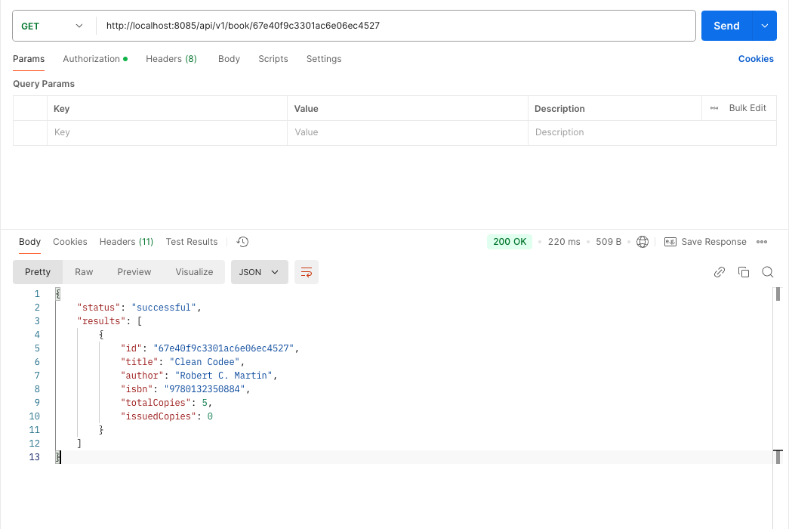

Get all books

* Borrowing and Returning: Successfully validated through API calls, ensuring accurate data representation in the borrow records and real-time inventory tracking.

Borrow invalid book

Borrow a book

Handover a book

Screenshots from application interfaces and API responses are provided to demonstrate successful functionality and operational efficiency.

# Conclusion and Future Work

The hybrid database system implemented demonstrates a robust approach suitable for complex real-world applications. Future enhancements could include real-time user notifications, machine learning-based book recommendations, and enhanced user analytics, significantly expanding the system’s capabilities and user experience.